Edmonton and Area Fetal Alcohol Network Society
Membership Form 2020 - 2021

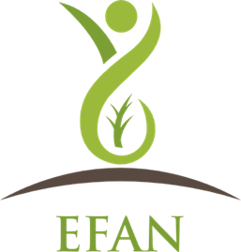

First, Last Name:

Organization:

Email address:

Work Phone:

Work Address:

City, Province:

Postal Code:

This Membership is for:

Individual:

Program:

Agency:

Please check the box that applies to you

Voting Member:

Non-Voting Member:

Please Print form and return to the Network Coordinator.

Cheque payable to ‘Bissell Centre’
Mail Cheque or Cash to:
Edmonton and Area Fetal Alcohol Network Society
10320 146 Street
Edmonton AB T5N 3A2

